Mismatch Questions:

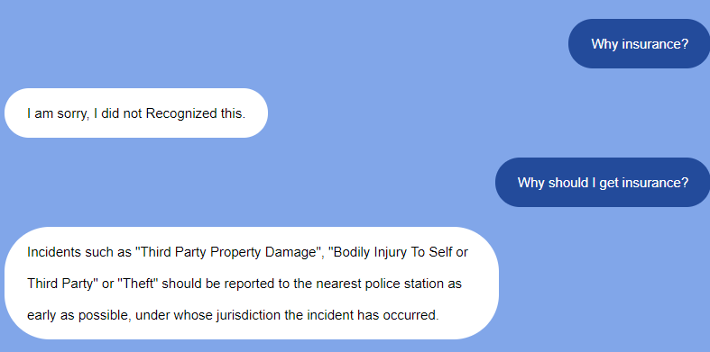

### [When should I report to the police?](javascript:__doPostBack('ctl00$innerPg$C133$ctl00$ctl00$ctl00$listsControl$ctrl0$listItemsControl$ctrl1$listItemToggleLnk',''))

Incidents such as "Third Party Property Damage", "Bodily Injury To Self or Third Party" or "Theft" should be reported to the nearest police station as early as possible, under whose jurisdiction the incident has occurred.

---------------------------------------------------------------------------------------------------------------

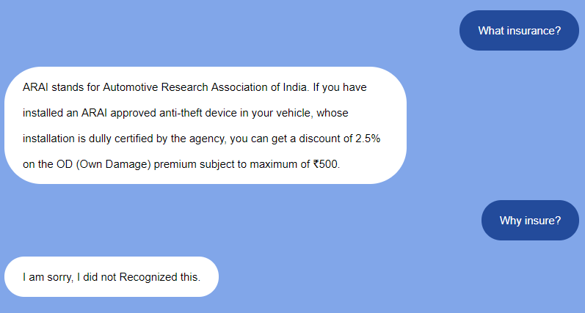

* [**What is meaning of insurance?**](javascript:__doPostBack('ctl00$innerPg$C129$ctl00$ctl00$ctl00$listsControl$ctrl0$listItemsControl$ctrl2$listItemToggleLnk',''))

Insurance is a protection against the financial loss arising on the happening of an unexpected event. A person can avail this protection by paying a premium to an insurance company.

* [**Why do I need to insure my vehicle?**](javascript:__doPostBack('ctl00$innerPg$C129$ctl00$ctl00$ctl00$listsControl$ctrl0$listItemsControl$ctrl6$listItemToggleLnk',''))

Your vehicle is probably one of the most expensive things you own. Insurance protects this asset and helps you cope with the financial loss caused by accidents, damage or theft. Another reason is that while driving, you are responsible for the safety of:  
• Your passengers  
• Your fellow drivers  
• Other people's property  
• Pedestrians  
• Yourself  
Insurance helps cover the costs of potential damages or injuries in case of an unforeseen accident or theft. Above all, in India it is mandatory to have at least a Third Party Motor Insurance before you can drive on the roads.

---------------------------------------------------------------------------------------------------------------

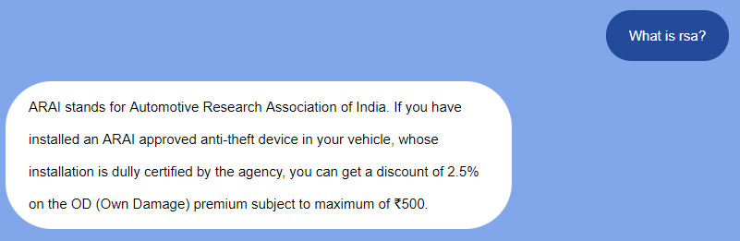

* [**What is Road Side Assistance (RSA)?**](javascript:__doPostBack('ctl00$innerPg$C129$ctl00$ctl00$ctl00$listsControl$ctrl0$listItemsControl$ctrl0$listItemToggleLnk',''))

Road Side Assistance is a service that provides you with the necessary help in case you are stranded on the road when your car breaks down. For example, breakdown cover may include jump starting an automobile, towing a vehicle, helping to change a flat tyre, providing a small amount of fuel when a vehicle runs out of it, or helping people who are locked out of their cars, etc.

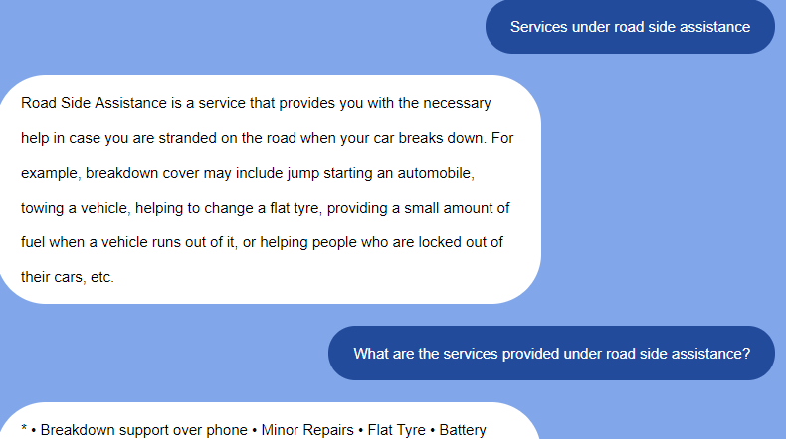

* [**Which are the services provided by ICICI Lombard under Road Side Assistance (RSA)? \***](javascript:__doPostBack('ctl00$innerPg$C129$ctl00$ctl00$ctl00$listsControl$ctrl0$listItemsControl$ctrl1$listItemToggleLnk',''))

• Breakdown support over phone  
• Minor Repairs  
• Flat Tyre   
• Battery jump start  
• Arrangement of keys  
• Towing on breakdown/accident  
• Arrangement of rental vehicle  
• Arrangement/ Supply of fuel  
• Arrangement of Accommodation  
• Message Relay  
  
**Note:** For details kindly refer [Policy wordings](https://www.icicilombard.com/docs/default-source/default-document-library/two-wheeler-package-policy.pdf?sfvrsn=0) from Web site for private car package policy.  
*For list of services applicable in a policy, please refer policy schedule.

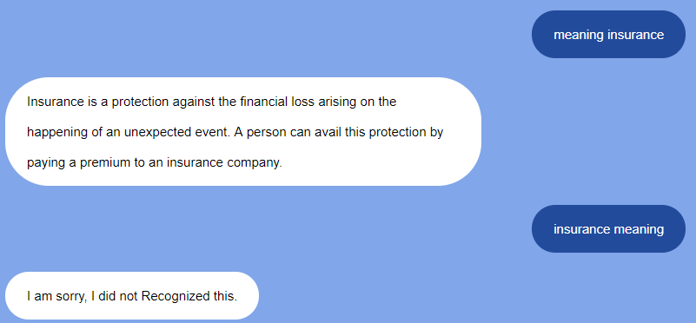

Should give same answer in both cases

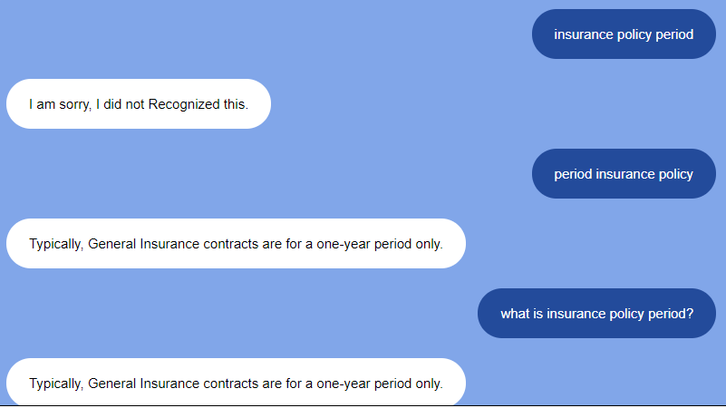

All should give the same reply

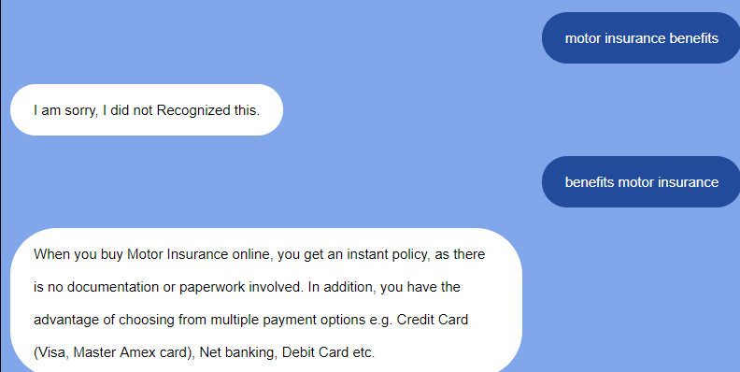

Should give answer for both ways of question

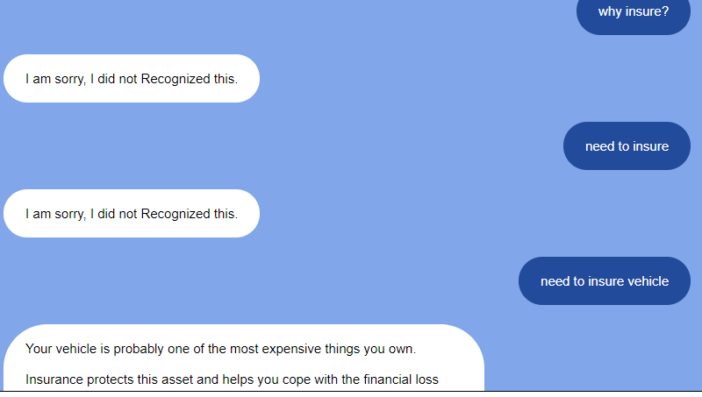

Ideally, it should be able to understand all this

* [**Why do I need to insure my vehicle?**](javascript:__doPostBack('ctl00$innerPg$C129$ctl00$ctl00$ctl00$listsControl$ctrl0$listItemsControl$ctrl6$listItemToggleLnk',''))

Your vehicle is probably one of the most expensive things you own. Insurance protects this asset and helps you cope with the financial loss caused by accidents, damage or theft. Another reason is that while driving, you are responsible for the safety of:  
• Your passengers  
• Your fellow drivers  
• Other people's property  
• Pedestrians  
• Yourself  
Insurance helps cover the costs of potential damages or injuries in case of an unforeseen accident or theft. Above all, in India it is mandatory to have at least a Third Party Motor Insurance before you can drive on the roads.

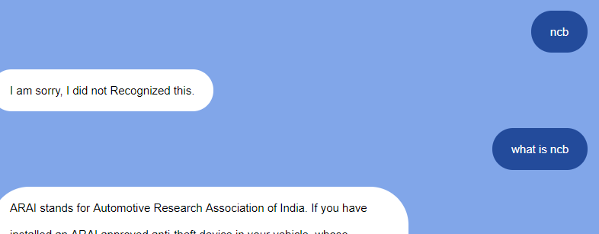

Wrong answer.

* [**What is No Claim Bonus (NCB)?**](javascript:__doPostBack('ctl00$innerPg$C129$ctl00$ctl00$ctl00$listsControl$ctrl0$listItemsControl$ctrl7$listItemToggleLnk',''))

No Claim Bonus (NCB) is a discount on premium of the Own Damage (OD) portion of your vehicle when you renew your policy, provided you have not made any claim during the last policy period. The NCB can be accumulated up to a maximum limit of 50% on OD premium.  
  
You can transfer the full benefits of NCB, even when you shift your motor insurance to ICICI Lombard from any other Insurance company.....

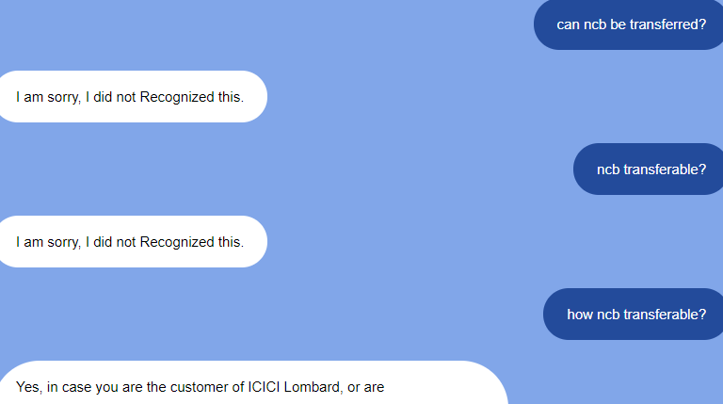

Should be able to answer all the versions

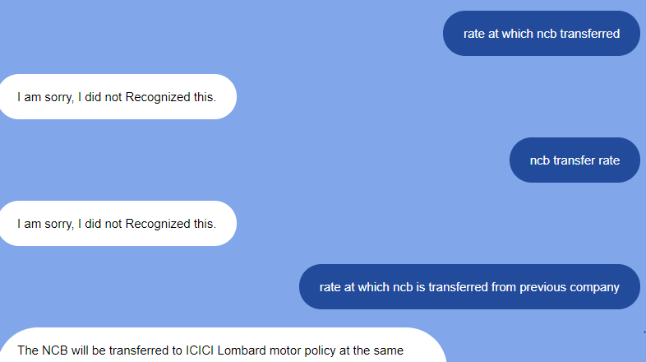

Should read all variations

* [**What is the rate at which NCB is transferred from my previous insurance company to ICICI Lombard?**](javascript:__doPostBack('ctl00$innerPg$C129$ctl00$ctl00$ctl00$listsControl$ctrl0$listItemsControl$ctrl9$listItemToggleLnk',''))

The NCB will be transferred to ICICI Lombard motor policy at the same rate that you are entitled to get from the previous insurance company on renewal of your policy. The NCB will be available, provided you show evidence that you are entitled to No Claim Bonus from your previous insurance company. Evidence can be in form of:  
  
• A renewal notice or  
• A letter confirming the NCB entitlement from the previous insurer or  
• A written declaration (kindly note that in case of a false declaration, the policy will be subject to cancellation)  
  
[Click here](javascript:;) to view the wordings of the written declaration

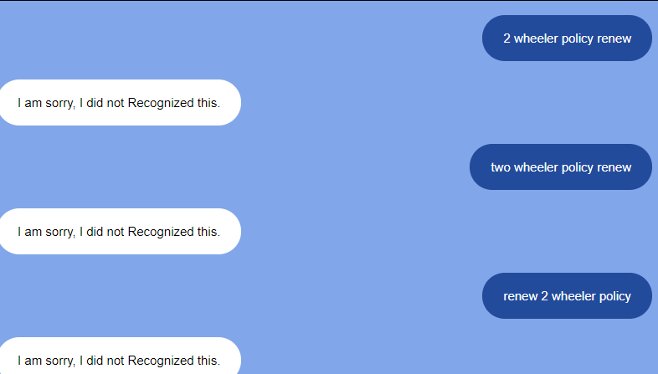

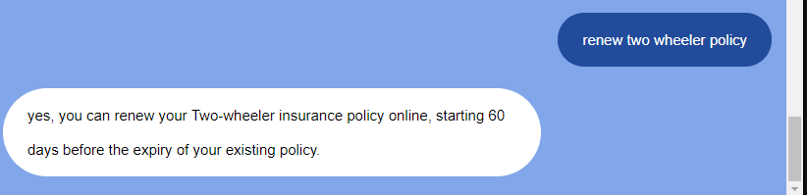

Should recognise all variations

* [**Can I renew my Two-wheeler insurance policy online?**](javascript:__doPostBack('ctl00$innerPg$C129$ctl00$ctl00$ctl00$listsControl$ctrl0$listItemsControl$ctrl10$listItemToggleLnk',''))

yes, you can renew your Two-wheeler insurance policy online, starting 60 days before the expiry of your existing policy.

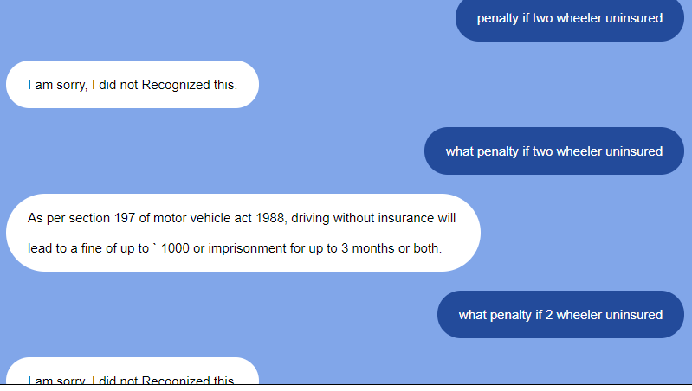

Should recognize all variations

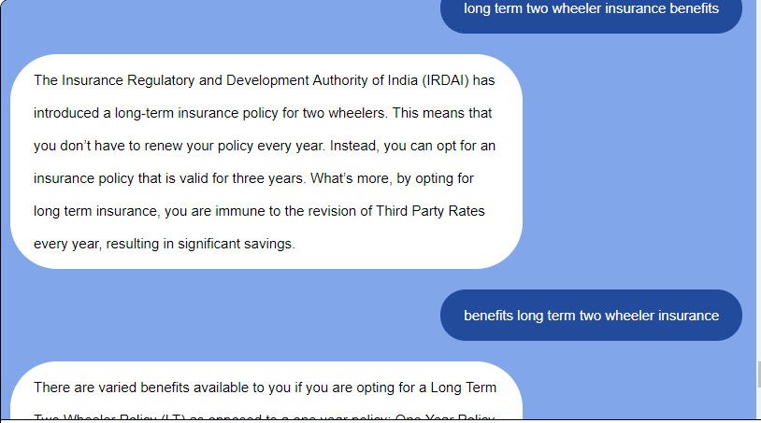

Should give same answer: Benefits

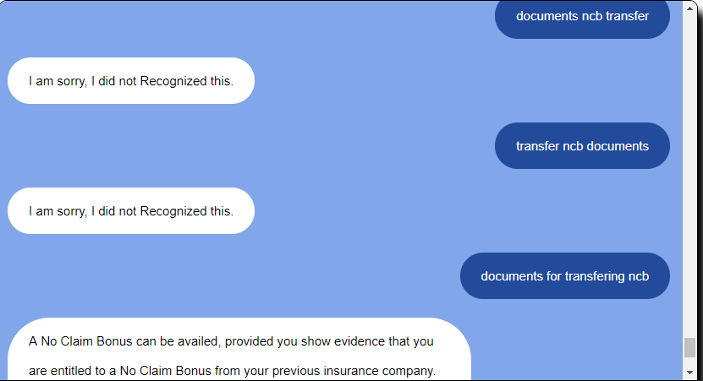

Should recognise all variations + wrong answer

Right answer:

* [**Which documents will I require to transfer my NCB?**](javascript:__doPostBack('ctl00$innerPg$C129$ctl00$ctl00$ctl00$listsControl$ctrl0$listItemsControl$ctrl15$listItemToggleLnk',''))

A No Claim Bonus can be availed, provided you show evidence that you are entitled to a No Claim Bonus from your previous insurance company. Evidence can be in the form of:

* + A renewal notice or
  + A letter confirming the NCB entitlement from the previous insurer or

A written declaration (kindly note that in case of a false declaration, the policy will be subject to cancellation)

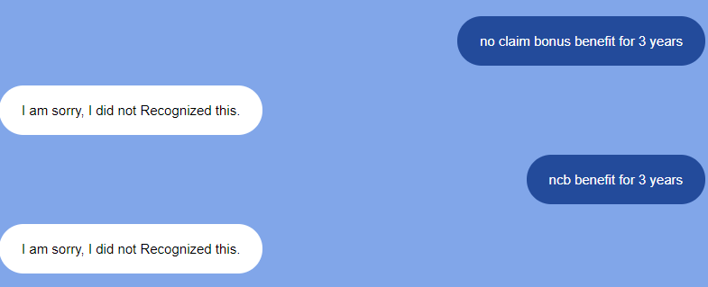

Missing question

**No Claim Bonus (NCB) Benefits for 3 Years**

* + No Claim During Policy Tenure - 40% NCB
  + One Claim During Policy Tenure - 30% NCB
  + Two Claims During Policy Tenure - 20% NCB

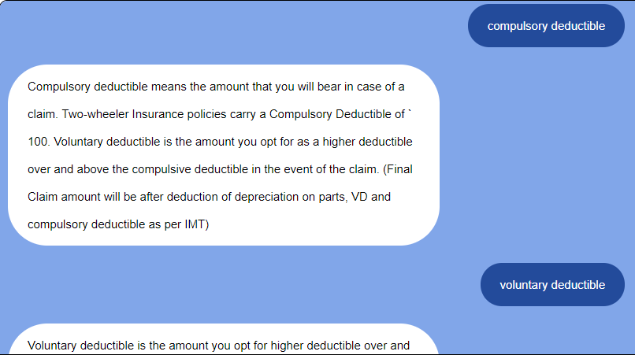

Can we break Compulsory and Voluntary deductible as 2 questions (voluntary is already a separate question)

I want when someone asks compulsory, only compulsory is answered. When asked voluntary and compulsory, both are answered

When only voluntary is asked (already a separate question)

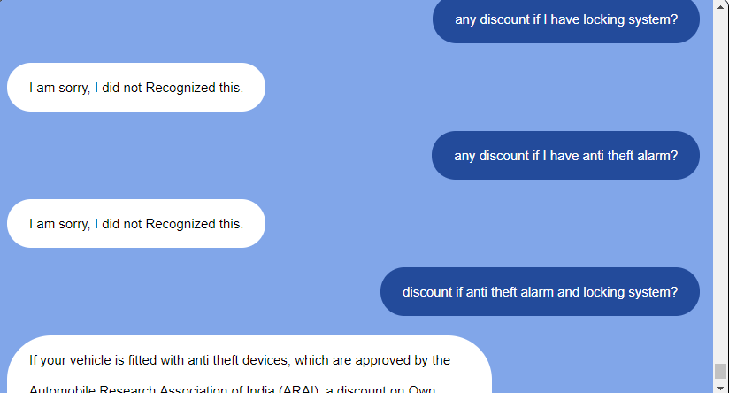

Should recognize all variations

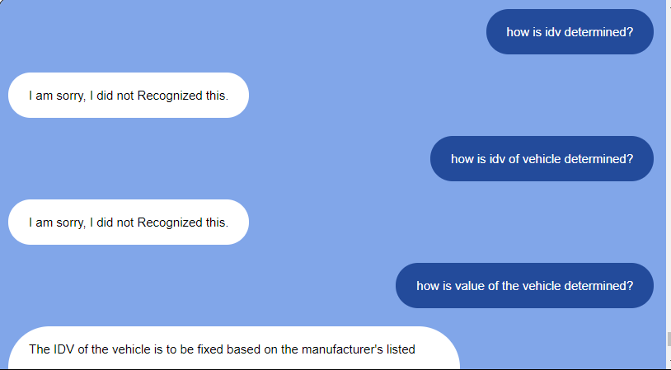

Should recognise all versions

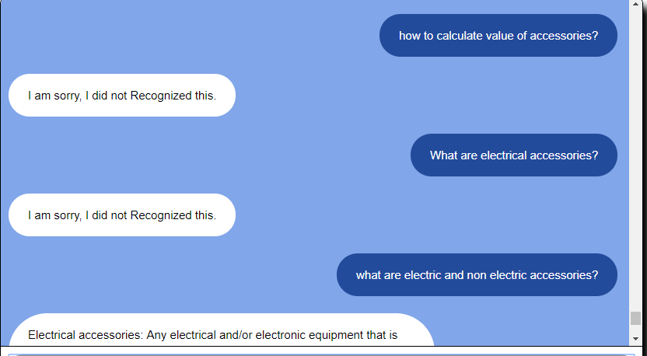

Should recognise part of the question too

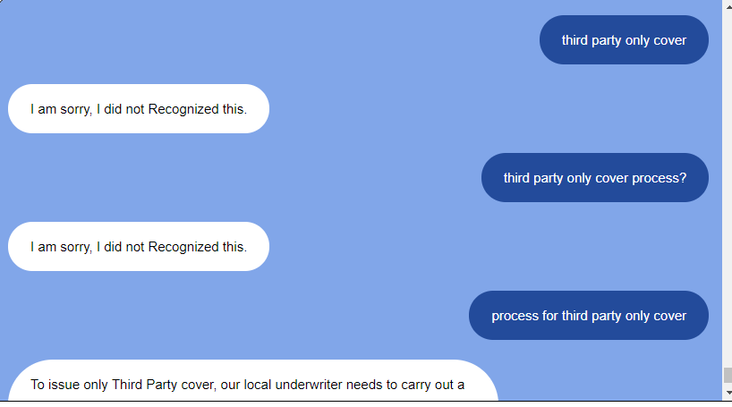

Should recognise all versions

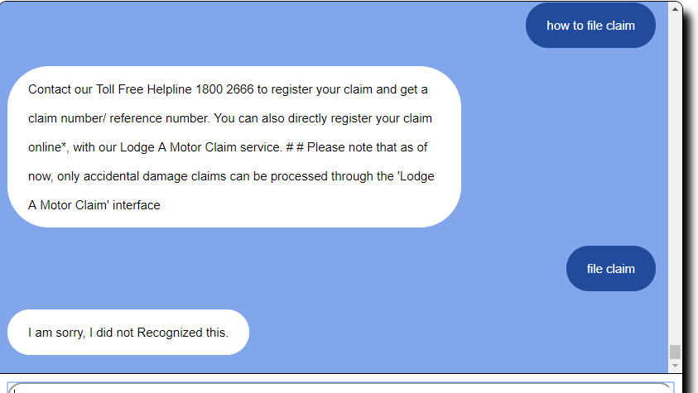

Should recognise short phrases

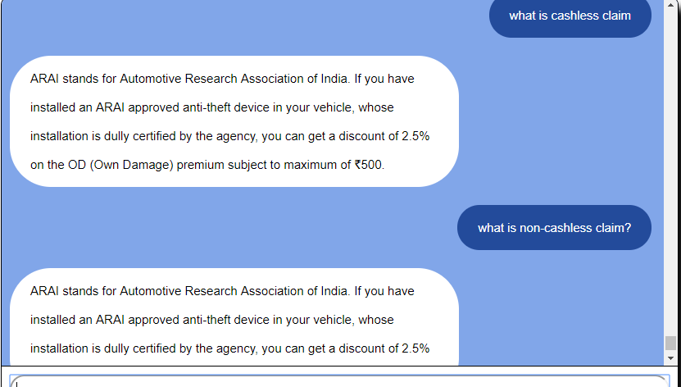

Wrong answer.

### [What is Cashless Claim and Non-cashless/ Reimbursement claim?](javascript:__doPostBack('ctl00$innerPg$C133$ctl00$ctl00$ctl00$listsControl$ctrl0$listItemsControl$ctrl2$listItemToggleLnk',''))

**Cashless Claim :** In cashless claim facility, the repair charges of the vehicle are directly paid to the garage by us, provided the vehicle is repaired in our garage network.  
  
**Non-cashless/ Reimbursement :** If the vehicle is repaired in a garage outside the purview of our network, then you will be liable to pay the repair charges of the garage. You can get your claim amount reimbursed by submitting the original bills and payment receipts to our office.

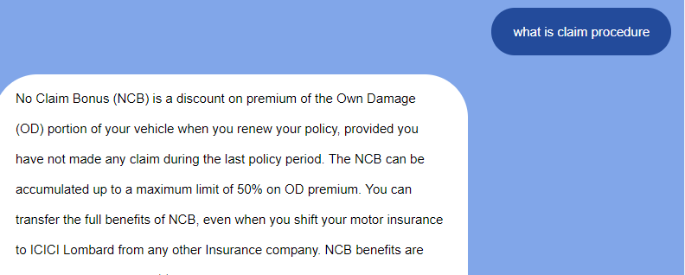

Wrong answer

### Right: [What is the claim procedure adopted by the company for settlements?](javascript:__doPostBack('ctl00$innerPg$C133$ctl00$ctl00$ctl00$listsControl$ctrl0$listItemsControl$ctrl3$listItemToggleLnk',''))

ICICI Lombard adopts the following process for settlement of claim:  
  
**For Cashless claim settlement -**  
• The Customer Relationship Manager (C​RM) / Surveyor attends the claim within 24 hours of registering the claim  
• Insured must fill the claim form, ([click here](https://www.icicilombard.com/docs/default-source/downloads/motor_claim_form.pdf?sfvrsn=0) to download it or collect it from the C​RM/ Surveyor/ Dealer) and submit all the required documents to the C​RM/ Surveyor/ Dealer  
• Our C​RM will get the estimate for the repairs of insured vehicle and give spot approval after assessment  
• After the completion of repairs at our preferred garage, we will make the payment of our share of the loss directly to the garage. Any amount over and above the admissible amount will have to be directly paid by the Insured  
• The amount of Depreciation as per the rate prescribed under the Indian Motor Tariff and Compulsory Deductions under the policy need to be borne by the Insured  
  
**For Non-cashless/ Reimbursement claim settlement -**  
• The Customer Relationship Manager (C​RM) / Surveyor attends the claim within 24 hours of registering the claim  
• Insured must fill the claim form ([click here](https://www.icicilombard.com/docs/default-source/other-documents/motor_claim_form.pdf?sfvrsn=0) to download it or collect it from C​RM/ Surveyor/ Dealer) and submit all the required documents to the C​RM/ Surveyor/ Dealer  
• The C​RM/ Surveyor assess the loss, estimates the repair amount and then informs the Insured on the same day of assessment. The C​RM/ Surveyor will also take photographs of the damaged vehicle  
• Insured can then get the vehicle repaired at preferred workshop/ garage. The C​RM later carries out a re-inspection of the vehicle. The Insured then pays the workshop/ garage as per the C​RM/ Surveyor’s assessed estimation, who thereafter releases a ‘Proof of Release’ document. (The proof of release is an authenticated document signed by the insured to release his vehicle from the garage after it is checked and repaired)  
• Insured needs to submit the original bill, proof of release and cash receipt (derived from the garage) to the C​RM/ Surveyor  
• The C​RM/ Surveyor then submits all required documents to ICICI Lombard for settlement of the claim  
• Upon acceptance of the claim, the company issues the cheque to the Insured within seven working days from the date of receipt of all documents  
• The amount of Depreciation as per the rate prescribed under the Indian Motor Tariff and Compulsory Deductions under the policy need to be borne by the Insured

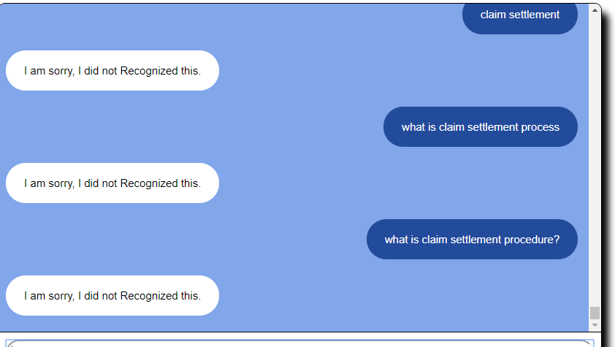

No answer for same question

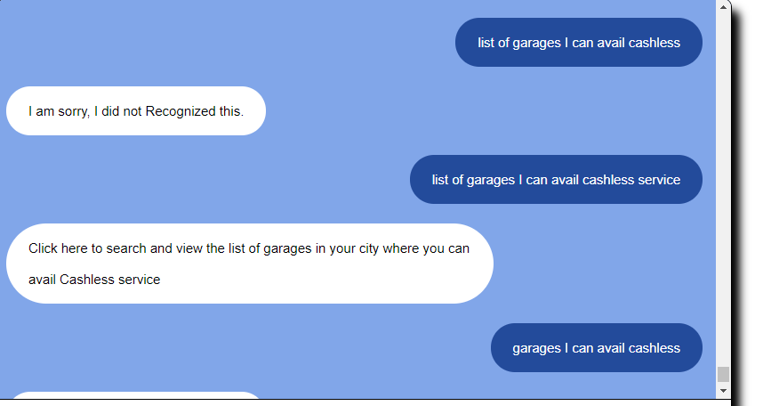

Should recognise all

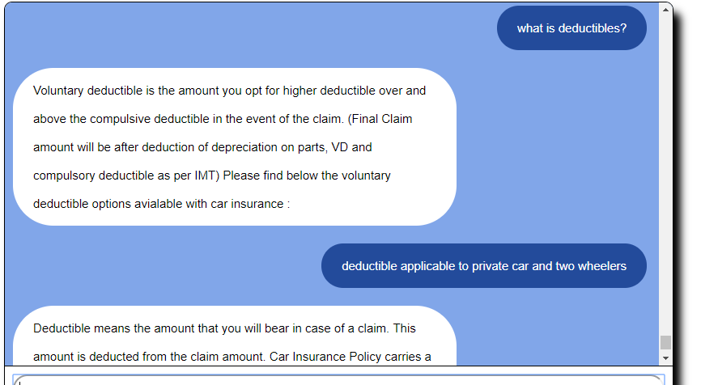

First answer is wrong, it is answer of Voluntary Deductible

### Correct Answer: [What is the meaning of deductibles? What is the deductible applicable to Private Car and Two-wheeler?](javascript:__doPostBack('ctl00$innerPg$C133$ctl00$ctl00$ctl00$listsControl$ctrl0$listItemsControl$ctrl6$listItemToggleLnk',''))

Deductible means the amount that you will bear in case of a claim. This amount is deducted from the claim amount. Car Insurance Policy carries a Compulsory Deductible of ` 1,000 (for vehicles not exceeding 1500 cc) or ` 2,000/- (for vehicles exceeding 1500 cc). Two-wheeler Insurance policies carry a Compulsory Deductible of ` 100.

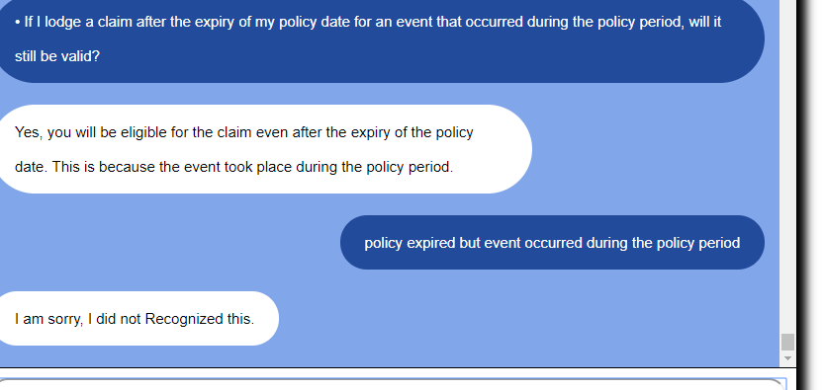

Should recognise this